**September Monthly Report**

Zihan Qiao (Weibo)

**The workflow of Weibo in September**

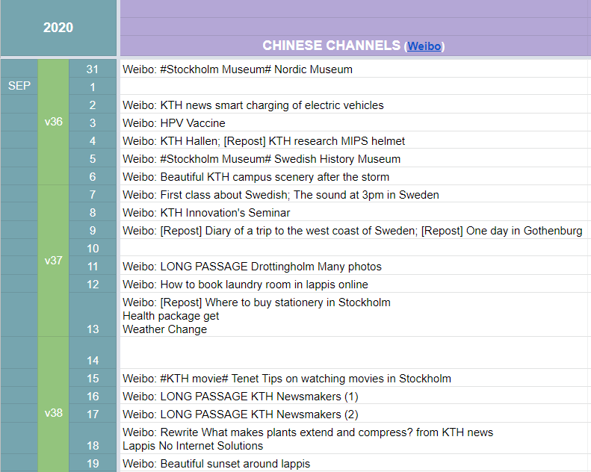

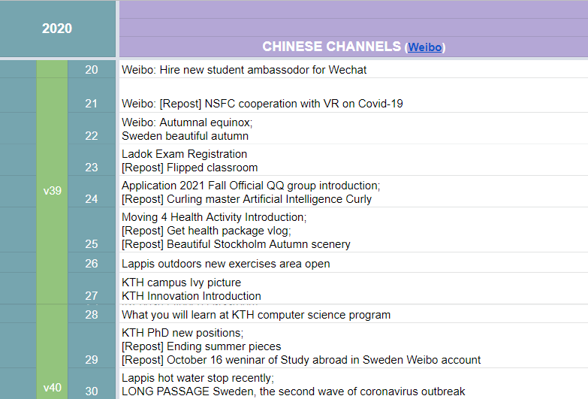

Figure 1 Content Sheet for September

The number of long passages: 4;

Missed days: 3;

**Statistics**

The weibo has changed its permission. Cannot see the statistics about the fans number.

Until 2020/11/1, there are 21762 fans. There are 3916 new followers.

**Shining point:**

1. More vlogs, although repost from one active KTH newly admitted master student, who is also from China.
2. Focus on the KTH newest research more.
3. The long passage which is related to the coronavirus situation in Sweden.
4. Quick reaction with direct message asking questions.

**Weaknesses:**

1. Too much information related to Chinese students already at KTH, few information towards the hidden applicants and their parents in China.
2. Three missed days. If too busy or lazy to send a post, I should use repost.
3. Too much detailed information which is not appealing. They can be seen as amount but not very good quality.

**September Plan Check:**

*Swedish songs topic* Unfinished

*Finish the passage series for the figures on the notes.* Unfinished

*Actually have read a lot and watched documentary about Birgit Nilsson, but have not finished the passage.*

*Add more scenery pictures.* Finished

*Organize an activity with my followers. Like write down your feeling about KTH. Repost and something like lottery draw. If we have some KTH related things which can be gifts.* Unfinished

Actually, this idea is kind of abandoned. Because it seems that the interactive with Chinese followers is not so warm as I assume. If struggle with the activity, may face embarrassing situation, like few comments.

**Personal feelings**

This monthly report is so late. Actually I should sent this file to you in the beginning of October, however due to my laziness, it comes to the first day of November. I should reflect on myself deeply.

There will be more content in the October monthly report. Since it already is a late report, there is no need to write the plan for the October, which has passed.

For this report, more information can be found in the Strengths and Weaknesses Section.

Writing time: 2020/11/1 20:20-20:45